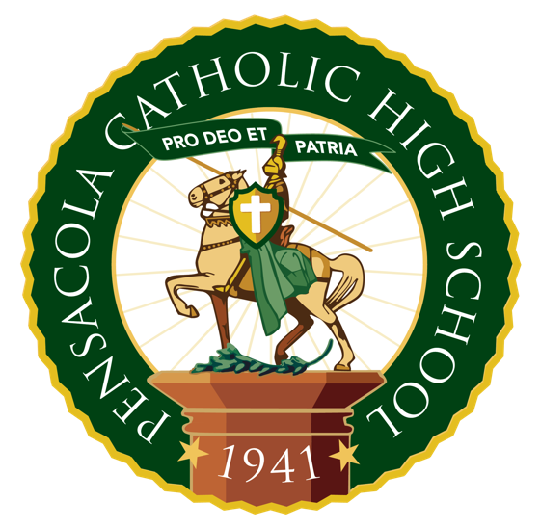

Application for Financial Aid must be made online. Links to the application documents are located on the CHS website (pensacolachs.org) under the Admissions/Tuition and Financial Aid tab. To be considered for financial aid, it is mandatory to complete an application online at FACTS Grant & Aid.
The completed Grant & Aid Application, accompanied by a copy of your 2022 or 2023 IRS Form 1040 with all schedules and your 2023 W-2 forms and an application fee, are due to FACTS Grant & Aid Assessment by March 1, 2024. The determination on financial need will not be made until the application and all supporting documentation have been submitted and verified by FACTS Grant & Aid.

The Second Source of Financial Aid
is State-Funded Scholarships
Pensacola Catholic High School accepts the following state-funded scholarships. ALL Florida residents are eligible regardless of income. Every family is encouraged to apply via www.stepupforstudents.org OR www.AAAscholarship.org Families may use only one state-funded scholarship.
- Florida Tax Credit Scholarship (FTC)
- Family Empowerment Scholarship for Educational Options (FES-EO)
- Family Empowerment Scholarship for Students with Unique Abilities (FES-UA)

If your family is applying for any state-funded scholarship(s), it is imperative that the CHS Finance Office be notified. You are responsible for the full cost of your child’s attendance until an award letter and/or confirmation of enrollment is received from the funding entity (i.e. Step Up For Students, or AAA Family.

(continued in next column)

Important Upcoming Dates
for Admission to the
2024-2025 School Year

- CHS Financial Aid Applications Available
January 10, 2024

- Financial Aid Applications Due
March 1, 2024

- FACTS Tuition Payment Plan
Enrollment Deadline
February 1, 2024

- CHS Financial Aid Announced to Families
Mid-April, 2024, via FACTS

- First Tuition Payment and Laptop Lease Fee
due, on or before, May 10, 2024

“Our Mission is to develop
responsible Christian individuals
by providing the finest in
Catholic education.”

PENSACOLA CATHOLIC HIGH SCHOOL

Finance Information &
CHS Financial Aid Program

2024-2025

It is the hope of Pensacola Catholic High School that any family who wishes to give their child the benefit of a Catholic High education will be enabled to do so.

Pensacola Catholic High School
3043 West Scott Street
Pensacola, FL 32505

Phone: 850-436-6400
Fax: 850-436-6405
www.pensacolachs.org

Student Laptop Lease Fees
All students must enter a lease-to-purchase agreement with CHS in order to acquire a school-assigned MacBook. The lease fee will be for 48 months and is paid in conjunction with the tuition payment schedule selected by the parent, all of which begin in May, 2024, for 2024-2025 school year.
Class of 2025: $58/mo. $696/yr.
Class of 2026: $55/mo. $660/yr.
Class of 2027: $55/mo. $660/yr.
Class of 2028: $58/mo. $696/yr.
(Laptop Insurance is Included in this amount.)

Registration Fee for 2024-2025
For Returning 10th-12th Graders
Until January 19, 2024 $ 150
After January 19, 2024 $ 200
For Incoming 9th Graders
Until January 24, 2024 $ 200
After January 24, 2024 $ 250
(Registration fees are non-refundable.)

Athletic Fee
Families with a student-athlete must assume responsibility for buying/selling one Athletic Raffle ticket @ $100 for each sport in which the student participates (limit 3) OR the amount due will be added to the student’s annual tuition.

Crusader Activity Fee
The $115 Crusader Activity Fee funds three services:
1. It includes membership in the CHS Student Council and provides the Class T-Shirt for all members.
2. The annual student fundraising contribution.
3. It funds admission to every home, regular season athletic event for each student for the entire year.
Payment of the $115 Crusader Activity Fee is due by September 30, 2024.

Capital Improvement Fee
Beginning with the Class of 2028, CHS is implementing a Capital Improvement Fee of $900 per year, payable by April 10, 2024.
Tuition and Fees for 2024-2025
Tuition rates are promulgated in January of each year.

Textbook and Annual Fees
Textbook fees vary with course selection. The estimated cost range for books, digital licenses, and other fees ranges from $500-$825 per student. Textbook costs and annual fees must be paid in full before the first day of school.
Adaptive Education Program (AEP) Fee
Each student enrolled in the AEP pays a fee that ranges from $50-$400, depending on the level of support received by the student.

Sources of Financial Aid for CHS Students
There are two sources of Financial Aid for CHS students.
The first source is:
CHS-Funded Financial Aid
This source of Financial Aid is funded solely by CHS for those in need of financial assistance for tuition and/or laptop fees.
Catholic High School uses the services of a third-party vendor, FACTS Grant & Aid Assessment, to assess financial need. CHS attempts to assist families whose ability to invest in private school education is less than their incurred costs.
Financial Aid Applications are available to anyone who has a registered student at Catholic High School. All financial aid granted to CHS students (for tuition and/or laptop assistance) is granted on the basis of family financial need.
For returning students, Financial Aid applications are available in January. For incoming Freshmen, the applications are available at the time of registration. A new application must be submitted each school year.
Once a determination on a family’s application has been rendered by FACTS Grant & Aid, the CHS Finance Office will inform parents—typically by the middle of April—of the amount of tuition assistance and/or laptop assistance to be granted. These amounts are determined by the difference between the tuition/laptop lease amount and the Effective Family Contribution as determined by the FACTS application.

(continued in next column)
Annual Tuition Rates*
 | Affiliated | Non-Affiliated
1 Student | $ 8,120 | $ 9,620
2 Students** | $15,676 | $18,676
3 Students** | $23,232 | $27,732
Monthly Payment
1 Student | $ 677 | $ 802
2 Students** | $1,307 | $1,557
3 Students** | $1,936 | $2,311

*Affiliated status is verified by CHS contacting the pastor of the parish indicated on the registration card. The affiliated discount is funded by CHS.
**These amounts include a discount for families with more than one student.

Tuition Payment Plans
Tuition payments may be made according to several payment plan options: annual, semi-annual, quarterly, or monthly over 12 months using a FACTS tuition payment plan (the Diocesan-mandated payment method).
For the 2024-2025 school year, the first tuition payment, on any payment plan, is due by May 10, 2024. Personal or company checks will not be accepted after April 10, 2025. Payments after this date must be in the form of cash, cashier’s check, or money order.
Our tuition policy states: Any time a family’s account is more than one month behind, the student(s) will not be permitted to attend class. Once the account is current, the student(s) may return to class. In order to avoid impacting your student’s education, please make all monthly payments by the 10th of each month. Any family in violation of this policy will also receive an invoice for the specific amount due from the CHS Finance Office.

Early Withdrawal
If a student withdraws from school prior to the beginning of the school year, two months of tuition is non-refundable. If a student withdraws from school once classes have begun, tuition, up to and including the quarter in which the student withdraws, is non-refundable. Between May and August of 2024, families must remain current in their monthly tuition payments in order to hold their child’s spot for the 2024-25 school year.

